Experiment No. 1

Title: Setting Up Environment

Roll No.: 16010420075 Experiments No.: 1

Aim : To set up the environment

\

Resources : virtual box

Theory

VirtualBox is a robust x86 and AMD64/Intel64 virtualization tool that can be used in both the enterprise and at home. VirtualBox is the only professional solution that is freely available as Open Source Software under the terms of the GNU General Public License (GPL) version 2. It is not only a feature-rich, high-performance product for enterprise customers, but it is also the only professional solution that is freely available as Open Source Software under the terms of the GNU General Public License (GPL) version 2.

__________________________________________________________________________
IMPLEMENTATION AND RESULTS:
Steps to install VirtualBox:
- You can download the latest version of VirtualBox from the Virtual Box website: https://www.virtualbox.org/wiki/Downloads according to the version of your operating system Windows, Mac or Linux.
- Open the file, click next, next again, yes, and finish.
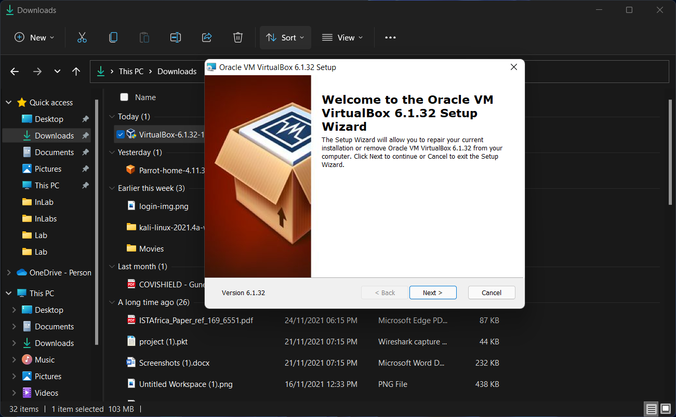
- 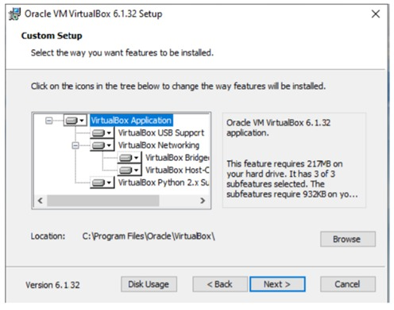
- 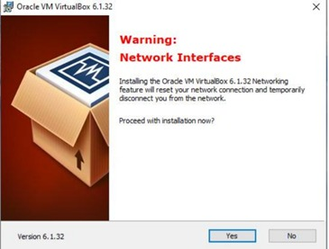
- 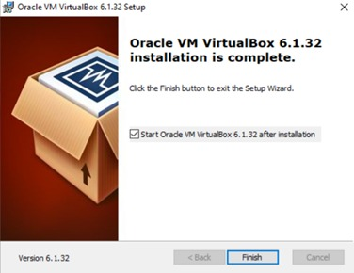
- At least, it will open VM VirtualBox in your system.
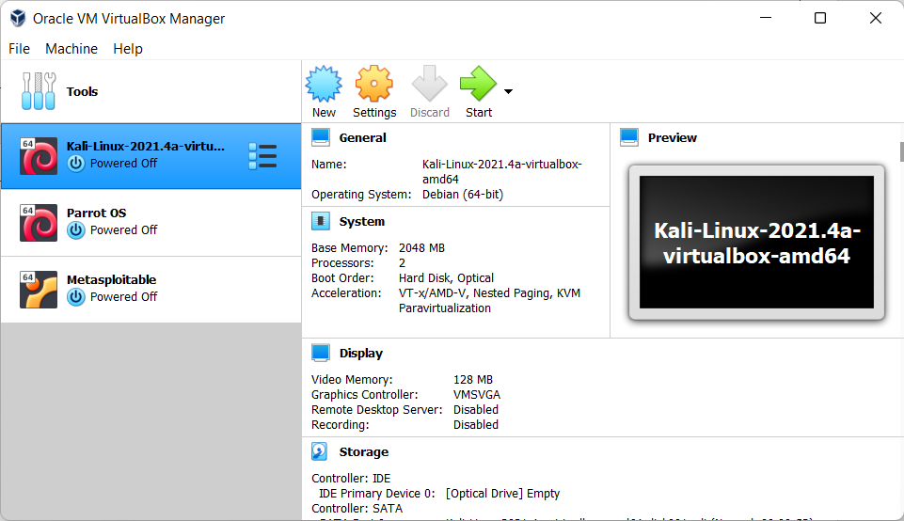
Outcomes:
_________________________________________________________________________
Conclusion: (Conclusion to be based on the objectives and outcomes achieved)
Environment was setup successfully and run to operate virtual OS.

Grade: AA / AB / BB / BC / CC / CD /DD

Signature of faculty in-charge with date

__________________________________________________________________________

REFERENCES:
www.virtualbox.org

